Ayush Goyal
190905522 CSE D 62

Distributed Systems Week 7: Lab 7: Election Algorithms

Lab Exercises:

Q1) Simulate a scenario in distributed systems to implement the Bully Algorithm for choosing a coordinator node amongst the participative nodes of the system after the collapse of the existing coordinator node in the system.

Code:

“bully.py”

import sys

noOfNodes = int(sys.argv[1])
initiatorNode = int(sys.argv[2])

def bully_algorithm():
print("BULLY ALGORITHM SIMULATION:")
print('Node %s notices the current coordinator %s has failed' % (initiatorNode, noOfNodes))
biggerNodes = []
for i in range(initiatorNode+1, noOfNodes):
print("%s sends ELECTION message to %s" % (initiatorNode,i))
biggerNodes.append(i)
for i in biggerNodes:
print("%s sends OK message to %s" % (i, initiatorNode))
while len(biggerNodes) != 1:
i = biggerNodes[0]
for j in range(i+1, noOfNodes):
print("%s sends ELECTION message to %s" % (i, j))
for k in range(i+1, noOfNodes):
print("%s sends OK message to %s" % (k, i))
biggerNodes.remove(i)
newCoordinatorNode = biggerNodes[0]
for i in range(0, newCoordinatorNode):
print("%s sends COORDINATOR message to %s" %(newCoordinatorNode, i))

if __name__ == '__main__':
bully_algorithm()

Output:

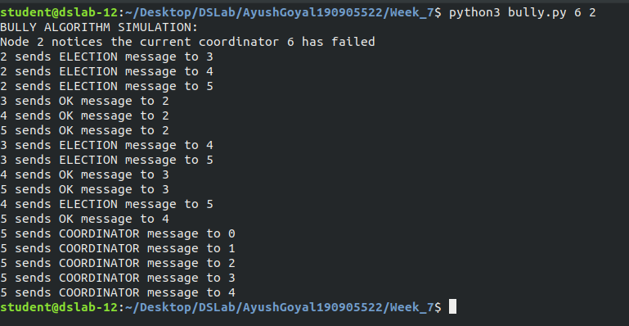

Q2) Simulate a scenario in distributed systems to implement the Ring Algorithm for choosing a coordinator node amongst the participative nodes of the system after the collapse of the existing coordinator node in the system.

Code:

“ringserver.py”

import sys
import threading
import socket
s = socket.socket(socket.AF_INET, socket.SOCK_STREAM)
host = socket.gethostname()
port = 7777
try:
s.bind((host, port))
except socket.error as msg:
print("bind failed" + str(msg))
sys.exit()
s.listen(10)
process_sockets_list = []
process_list = []
neighbor_list = []
msg_token = ""
def recv_message(conn):
while True:
try:
received = conn.recv(1024)
msg_token = received.decode('utf-8')
print("received token: " + msg_token)
except:
continue
if "Coordinator: " in msg_token :
le=msg_token.split()
leader=le[1]
process_index = process_sockets_list.index(conn)
if len(process_sockets_list)==process_index+1 :
to_process=0
else :
to_process=process_index+1
try :
process_sockets_list[to_process].send(received)
print("sending :" + received.decode('utf-8'))
except :
if process_list[to_process]!=leader :
process_sockets_list[to_process+1].send(received)
print("sending :" + received.decode('utf-8'))
process_sockets_list[to_process].close()
process_sockets_list.remove(process_sockets_list[to_process])
process_list.remove(process_list[to_process])
continue

while True:
try:
connection, addr = s.accept()
process_sockets_list.append(connection)
recv_process_id = connection.recv(1024)
from_to_process = recv_process_id.decode('utf-8')
process_list.append(from_to_process)
print("Process: " + from_to_process)
start_thread = threading.Thread(target=recv_message, args=(connection,))
start_thread.start()
except socket.error as msg:
print("thread failed"+msg)

connection.close()
s.close()

“ringclient.py”

import socket
import threading
import time
import sys
s = socket.socket(socket.AF_INET, socket.SOCK_STREAM)
host = socket.gethostname()
to_port = 7777
s.connect((host, to_port))
my_id = str(sys.argv[1])
s.send(my_id.encode('utf-8'))
leader="-1"
def initiate_election(s):
time.sleep(1)
s.send(my_id.encode('utf-8'))
print("token sent: " + my_id)
print("Election initiated")

def Ring_Election_Algorithm(s):
while True:
global leader
try:
s.settimeout(15)
received = s.recv(1024)
s.settimeout(None)
received_token_list = received.decode('utf-8')
except socket.timeout:
leader = "0"
initiate_election(s)
continue
if my_id in received_token_list and "Coordinator: " not in received_token_list and "hello" not in received_token_list:
leader = max(received_token_list)
forwarding_leader = "Coordinator: " + leader
time.sleep(1)
s.send(forwarding_leader.encode('utf-8'))
elif my_id not in received_token_list and "Coordinator: " not in received_token_list and "hello" not in received_token_list :
print("rec tok: " + received_token_list)
leader = "0"
received_token_list = received_token_list + " " + my_id
time.sleep(1)
s.send(received_token_list.encode('utf-8'))
print("adding token: " + received_token_list)
elif ("hello" in received_token_list or "Coordinator: " in received_token_list )and leader=="-1":
leader="0"
initiate_election(s)
elif "Coordinator: " in received_token_list and leader not in received_token_list :
print(received_token_list)
le=received_token_list.split()
leader=le[1]
time.sleep(1)
s.send(received_token_list.encode('utf-8'))
else :
if leader=="-1" or leader=="0":
continue
else :
print(received_token_list)
communicate = "hello" + " from " + my_id
time.sleep(1)
s.send(communicate.encode('utf-8'))
continue

recv_thread = threading.Thread(target=Ring_Election_Algorithm, args=(s,))
recv_thread.start()
recv_thread.join()
s.close()

Output:

Server Ouput:

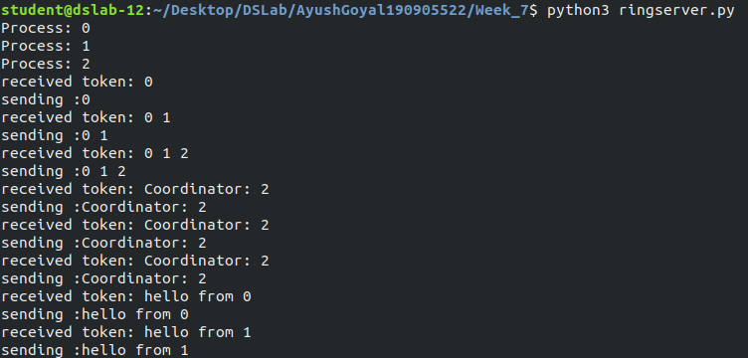

Client 1 Output:

python3 ringclient.py 0

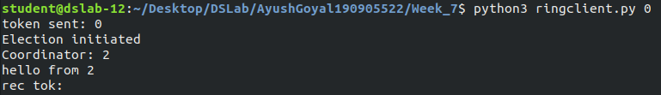

Client 2 Output:

python3 ringclient.py 1

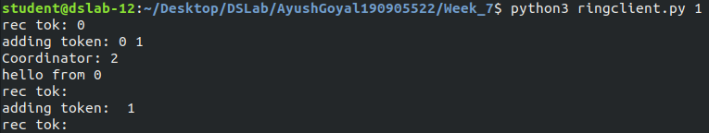

Client 3 Output:

python3 ringclient.py 2

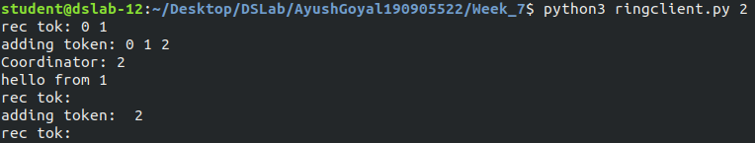

THE END

